R Charitha

192373007

Push in Git:

1. 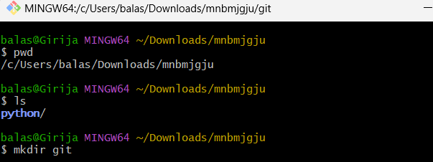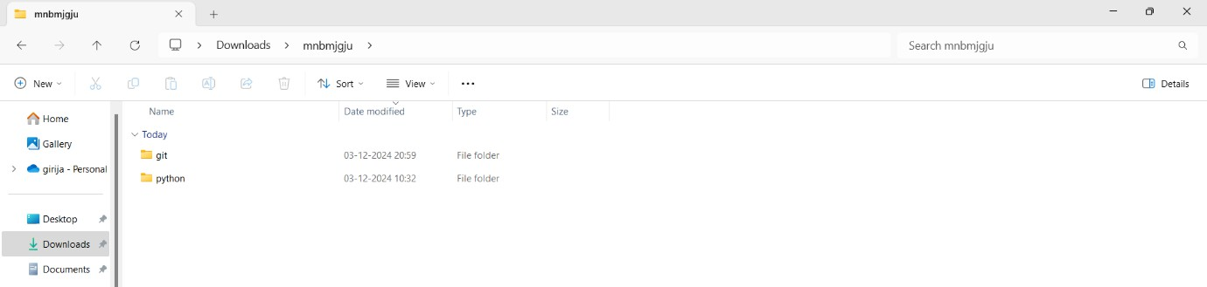Create one new folder named git using mkdir git command.
2. Create a new file named file.txt under the new folder using echo “hello world” >> file.txt.

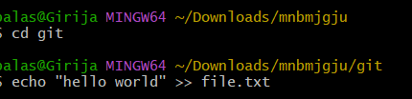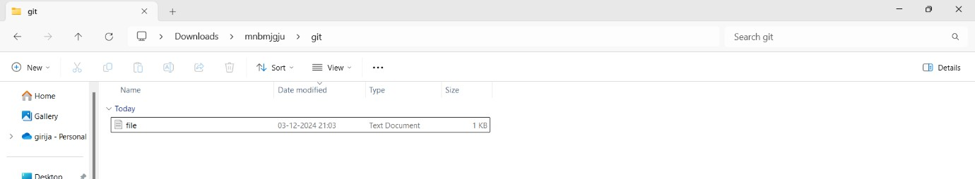

1. Give username and user email configuration as shown:

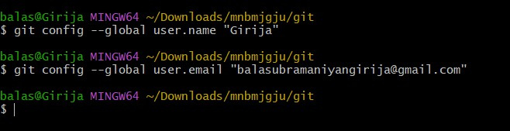

1. Confirm the configuration:

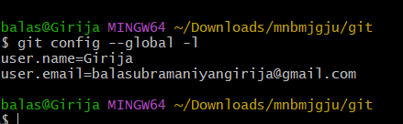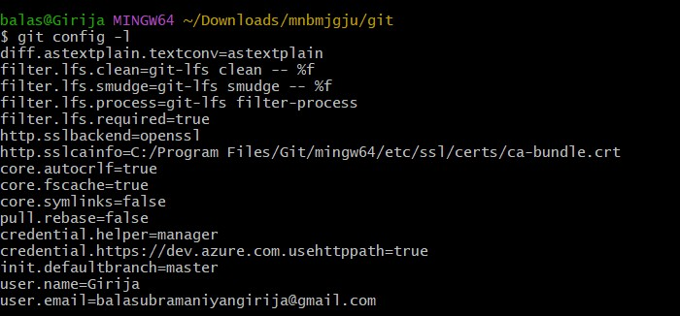

1. Initialize a New Repository in this folder using git init. Here new repository is .git.

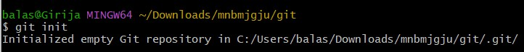

1. Verify the new repository in folder.

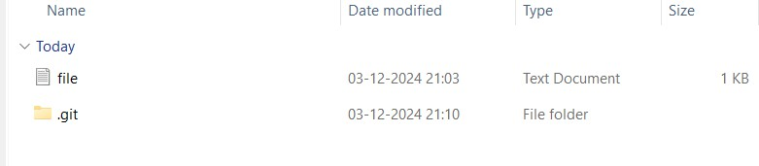

1. Type git status to check status.

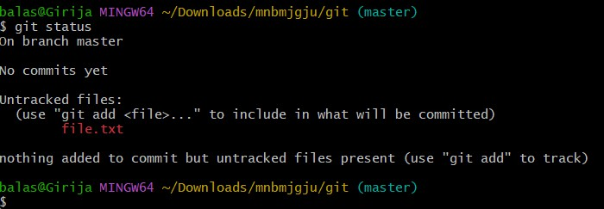

1. Type git add file.txt to make the file trackable.

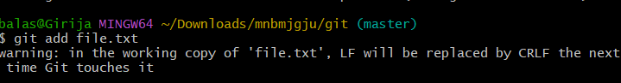

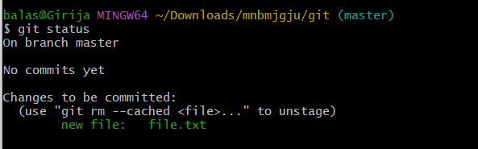

1. Type git log to check commit history.Since npo commits yet it display as not committed yet. Type git commit -m “initial commit”.

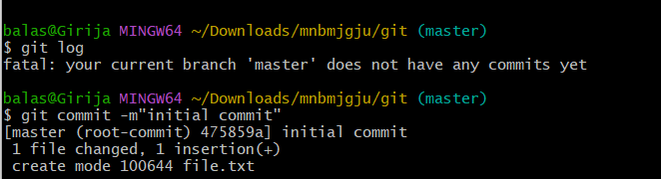

1. Now check the commit using git status and commit history using git log.

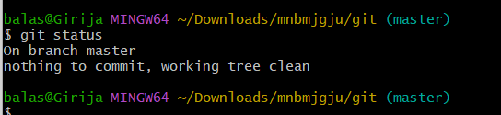

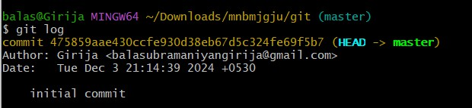

1. Now give name for the repository as test for sample and origin for the pushing file using git remote add.

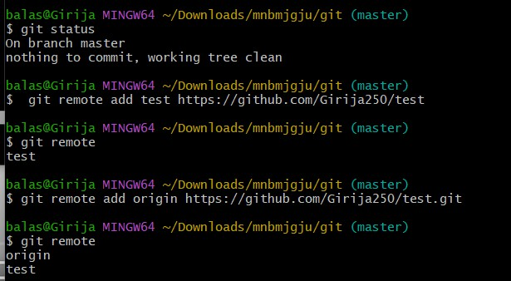

1. Change the branch from master to main using git branch -M command.



1. Type git push -u origin main to push the file to github repository.

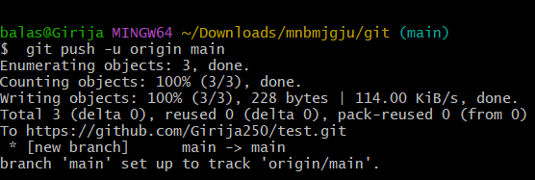

1. Open github profile and verify the file in the new repository.

